Created by: David Rubio G.
Blog: https://soceame.wordpress.com/
GitHub: https://github.com/DRubioG
Last modification date: 09/03/25

In this post I will discuss how to create a basic project with Libero.

Creating a project
The first step to working with Libero is to open the tool.
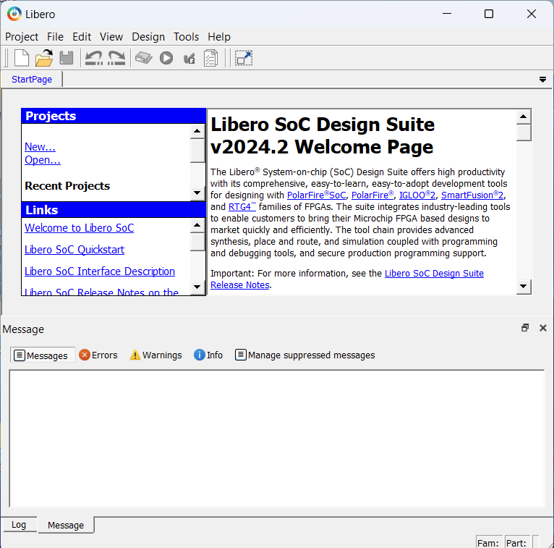
Once opened, we tell it that we want to create a new project.
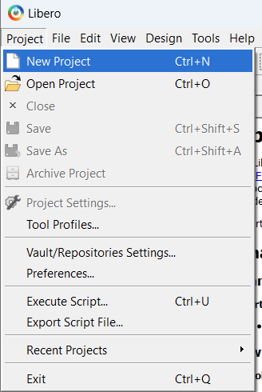
Then a tab for building the project opens. In the first part, it asks us what we want to call the project, where we are going to create it and the language we are going to use.
NOTE: it is worth remembering that the free Libero license does not allow the use of two languages ​​in the same project.
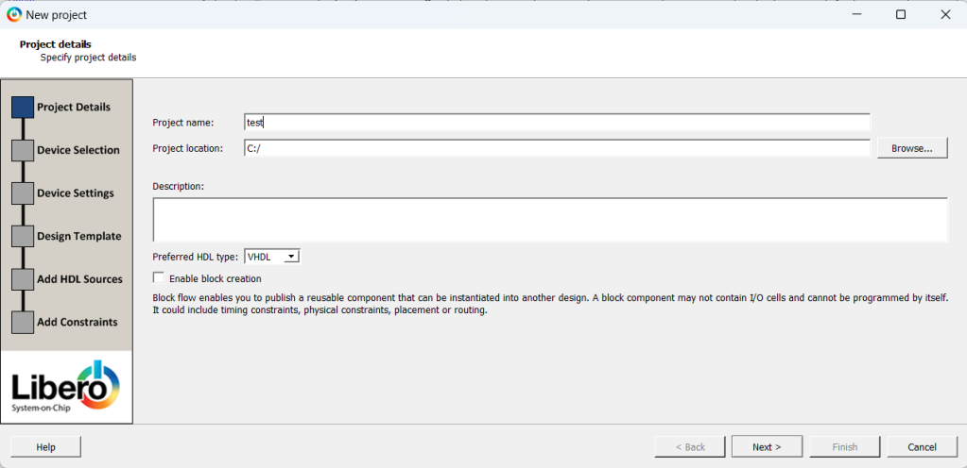
The next tab asks us for the device we are going to program.
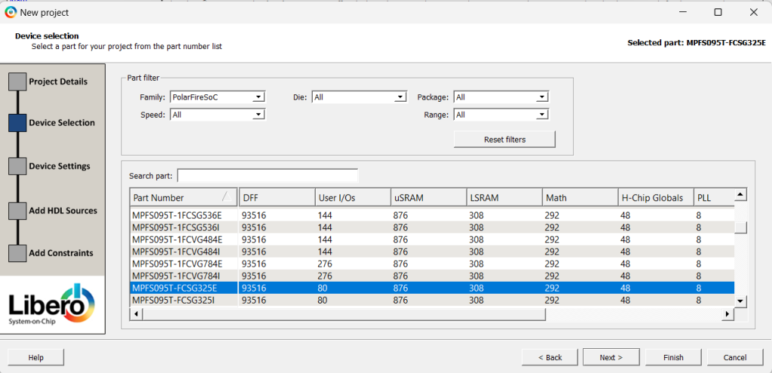
NOTE: if you haven't noticed, the Design Templates option has disappeared between the last two images. This is because you have selected to program a SoC that does not have a Cortex-M3 (the family that has the Cortex-M3 is the SmartFusion2). If you had chosen a SmartFusion2, this tab is the one that allows you to program the SoC (for the PolarFire SoC, it is done differently).
The next tab asks us for the core voltage and the default voltage of the pins. This influences when declaring the pins. It also asks us if we want to reserve pins for debugging. I will explain the ways to debug with Libero in another post.
NOTE: if you cannot change the voltage of the pins when declaring them, the problem is in the voltage defined by default. To access this option to change it once the project has been created, you have to go to the Project option, and inside look for Project Settings, and then Device settings.
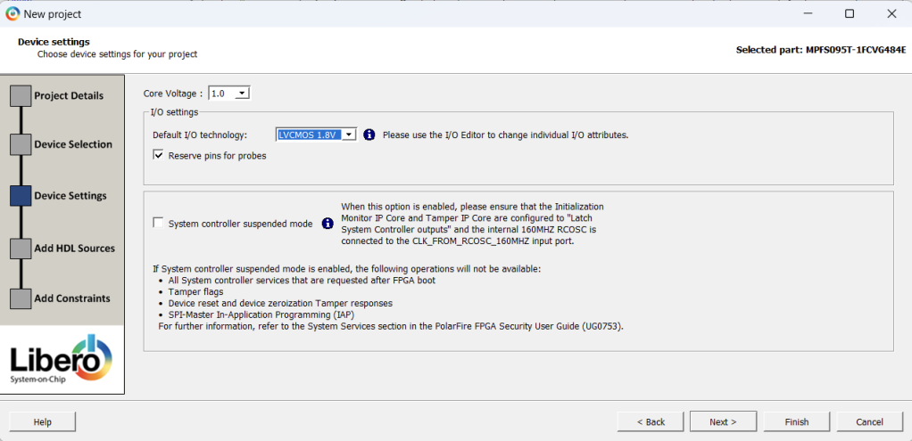
If we had chosen to program a SoC from the PolarFire family, we have to go to the Project option, and inside look for Project Settings, and then Device settings. SmartFusion2, this tab would appear, where it allows us to choose to program the SmartFusion2 as FPGA (None) or as SoC, giving us two options, allowing us to preconfigure it or configure it later.
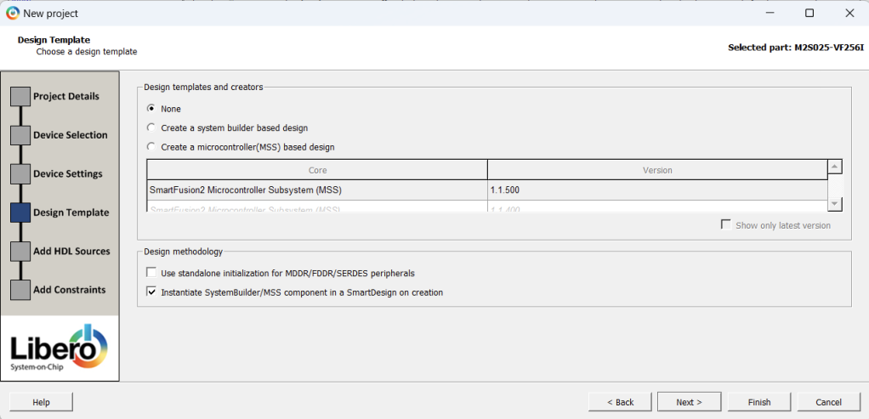
The penultimate tab asks us if we want to add or link a folder with source code.
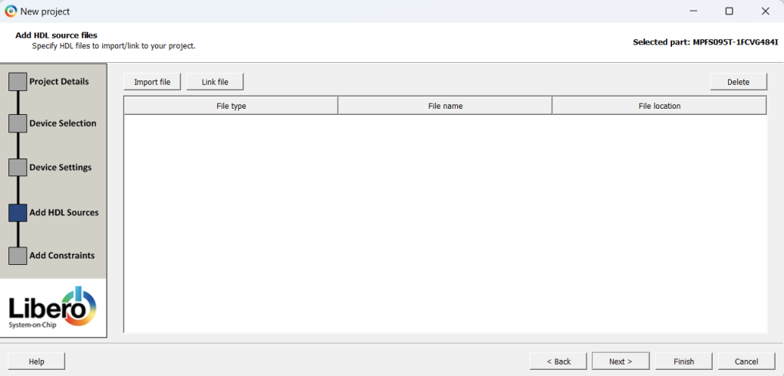
The last tab asks us if we want to add or link a file with restrictions.
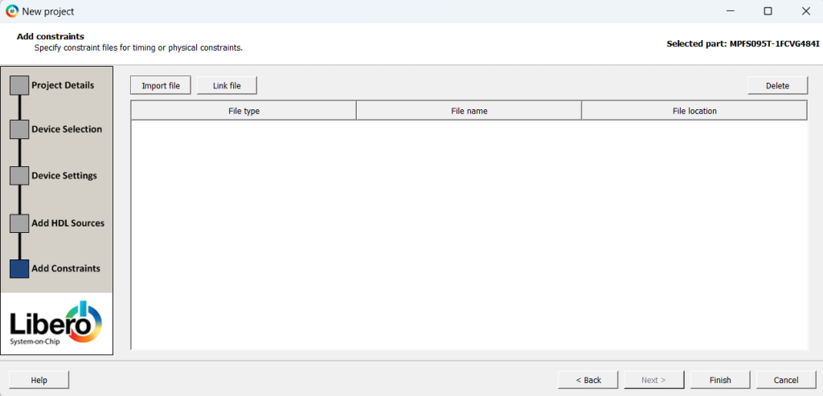
Once the project is created, the first step is to create an HDL file, to do this we click on the Create HDL option.
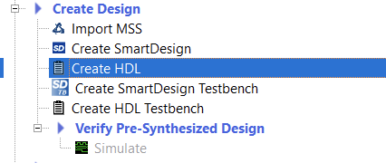
The next thing it asks us is the name of the file to be created and the language used.
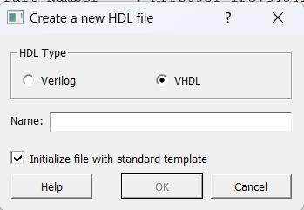
Once created, in the Design Hierarchy tab, the created file appears, but a message appears that says Please select a root, this is because we have not selected any file as the main one.
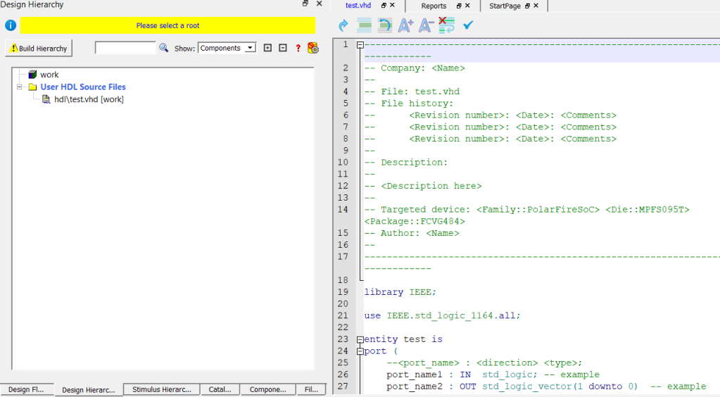
From the point where we are right now, we first have to click on the Build Hierarchy button, when we click it, the HDL file that we have created is uploaded to the work library.
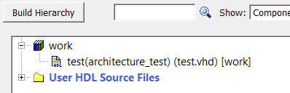
Afterwards, we right-click Set As Root, and the message disappears.
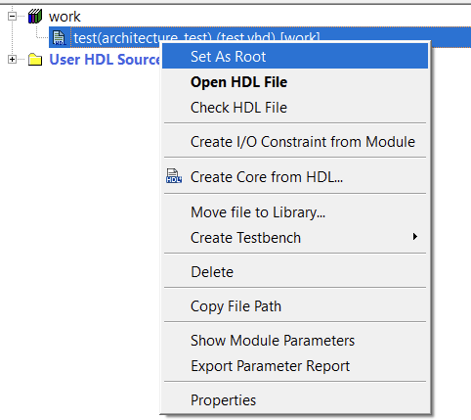
From now on we can develop the FW. Each new file that is added requires pressing the Build Hierarchy button again.

Working with blocks
In Libero there is another working option when working with FW, and that is the use of graphic blocks.
To work with them you first have to create a frame, Libero calls it SmartDesign.
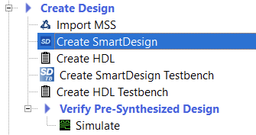
When creating a SmartDesign it asks us for a name.
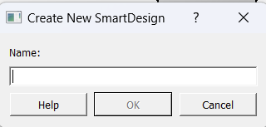
When creating the SmartDesign, the SmartDesign appears at the same level as the HDL code.
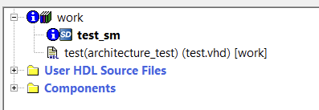
First you have to mark the SmartDesign as root and then you take the FW file and drag it to the SmartDesign. And the block appears, but without connections to the outside.
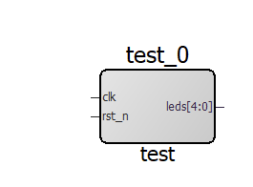
But clicking on the pins shows us an option called Promote to Top Level.
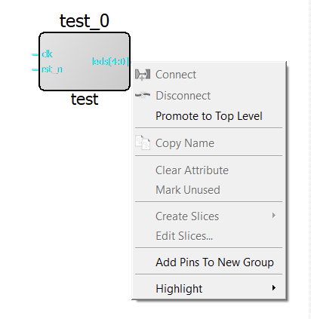
Once the pins have been created, we have to click on the yellow icon with the gear at the top left. Once the pins have been created, we have to click on the yellow icon with the gear at the top left.
If any problem occurs when clicking on it, it will inform us below of the errors that have occurred, mostly, these errors are due to unconnected inputs, so we have to specify the value they will have.
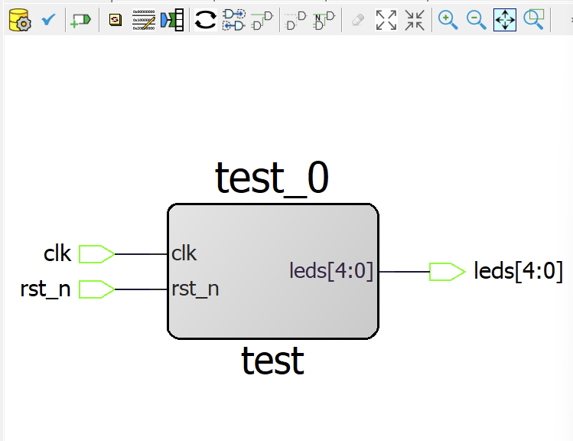
This icon makes the project structured.
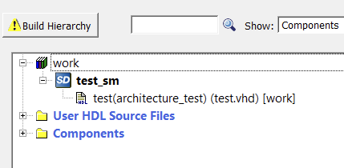
Now we just need to click on the Build Hierarchy button so that we can synthesize the project.

Generate the bitstream
Once we have it developed, returning to Design Flow, we can synthesize the project. Synthesizing the project also allows us to unlock the selection of FPGA pins, because the pins are collected from the synthesis.
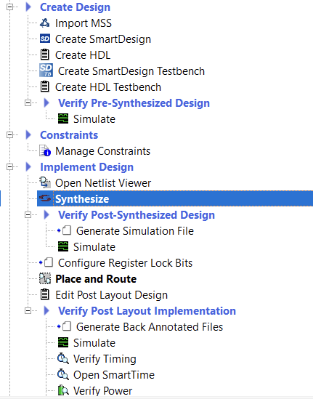
Once it tells us that the synthesis is correct, we open the Manage Constraints option.
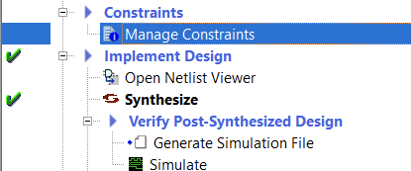
This option allows us to manage the different restrictions of the project, both pins and times, etc. Pin constraints generate a PDC file, while timing constraints generate an SDC file.
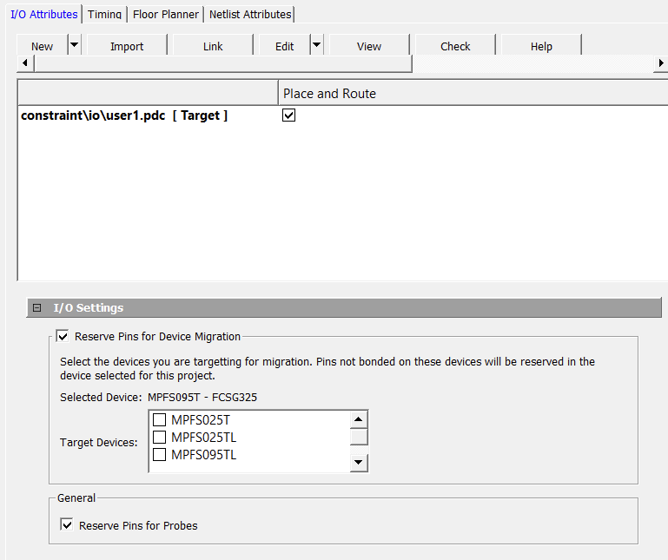
To create a pin constraint we have two options:
- Make the constraints by hand, which can be quite complex if you don't know the structure of the PDC file.
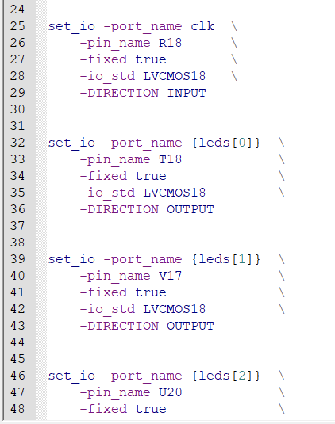
- The other option is to use the interactive tool provided by Libero. To access it, open the Edit drop-down menu and click on the Edit with I/O Editor option.
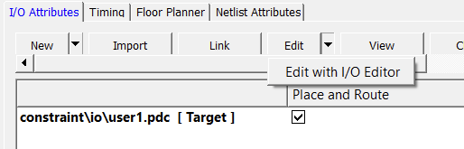
When you open this option, an interactive tool opens where the user can select the pin they want for the FW port.
NOTE: this tool works by banks, so that if you select a pin at a specific voltage, it sets the entire bank to that same voltage. Also, if you select a wrong pin and assign it to a different one, you can leave the entire bank marked at that voltage, and the pin selector will only let you use pins from that bank. It is advisable to be careful.
NOTE 2: to solve the problem of preselecting the pins, you have to manually delete the pin and press enter, so that it stops marking that pin. Many of the problems with this tool are solved by manually deleting the pin.
NOTE 3: if you cannot change the voltage of the pins that appears by default, you have to go to the Project option, and inside look for Project Settings, and then Device settings.
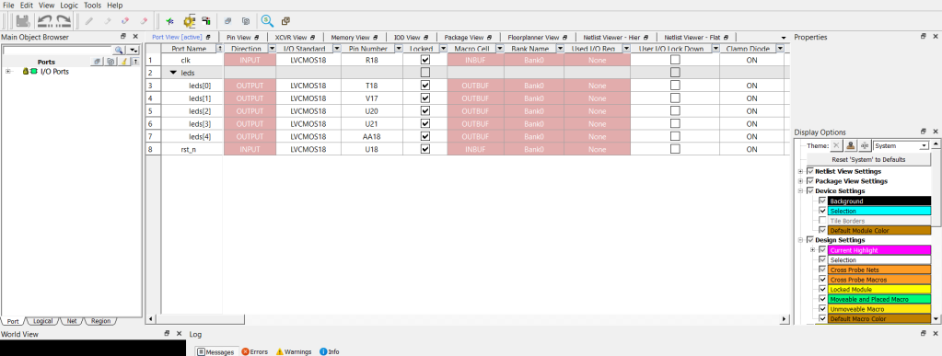
Once finished, you have to click on the save icon, and then create the pin restriction file for the project. The next thing to do is to mark the pin file as Target.
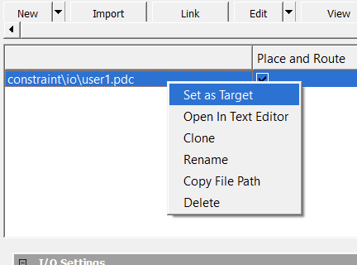
NOTE: This editor also allows us to see the synthesized model that Libero has generated for us, it is in the Netlist Viewer tab (if a blue message appears, just click on it to make it appear).
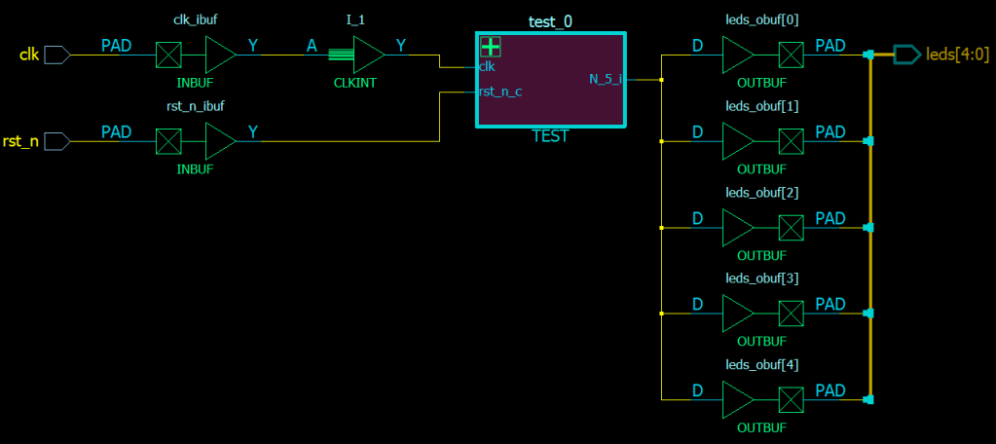
It also allows us to see other things, such as the location of the chip's pins or the type of selectable pins on the chip.
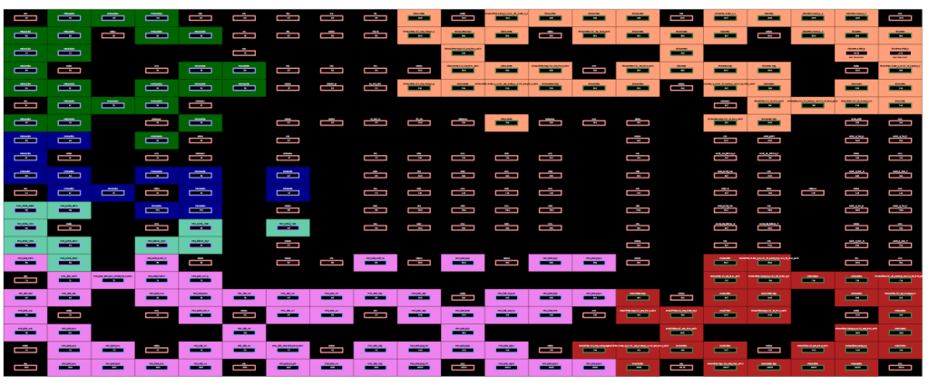
Once the pins have been selected, the implementation is carried out, to do this, click on the Place and Route option.
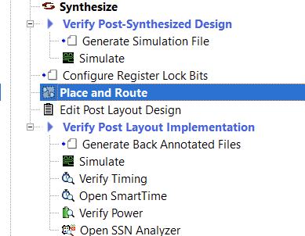
Once finished, the bitstream can be generated. To do this, select the Generate Bitstream option.
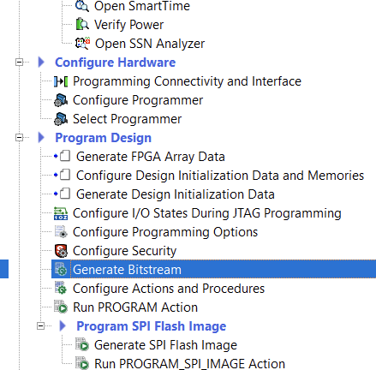
Once generated, we already have the project's bitstream generated, we just need to save it to the FPGA or export it.
- To save it to the FPGA, you have to connect the FPGA to the computer and click on the Run PROGRAM Action option. While it is being saved, this tab appears and below in Libero a bar appears with the bitstream loading status.
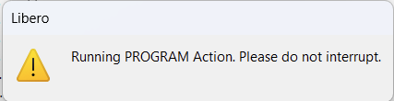
The Run PROGRAM Action option also has the option to perform more actions, to do this, right click on Run PROGRAM Action and click on Select Action. The PROGRAM action is to record the FPGA.
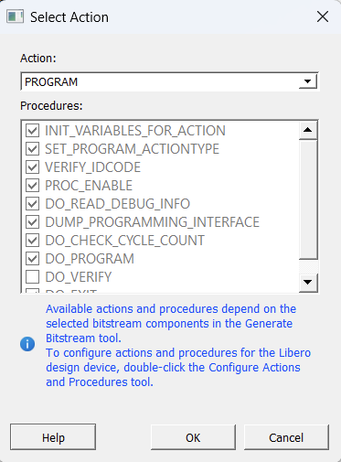
- To export it you have to go to the Libero export options. Here several options appear, the main ones are to export the bitstream and to export to generate a project in FlashPro Express.
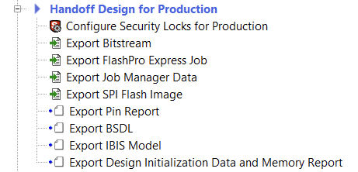
The two export options are described at the end of this previous entry.
https://soceame.wordpress.com/2025/03/09/flashpro-express-tutorial-installing-and-running/

